

İş başvurusu yapan adaydan bu doküman ile talep edilen çalışma, iş başvurunuzda değerlendirme amaçlı kullanılacaktır. T-HOS ile paylaşacağınız iş çıktıları, değerlendirme dışında başka hiçbir amaçla kullanılmayacaktır ve iş başvurusu yapan aday bu çalışma ile ilgili herhangi bir ücret talep etmeyeceğini kabul ve beyan etmiştir.

**QUESTION 1**

**—**

Create a sql query to list students that take all available courses using two tables below.

select * from CourseStudent s inner join Course c on s.CourseId=c.CourseID;

select * from CourseStudent s where s.CourseId in (select c.CourseID from Course c);

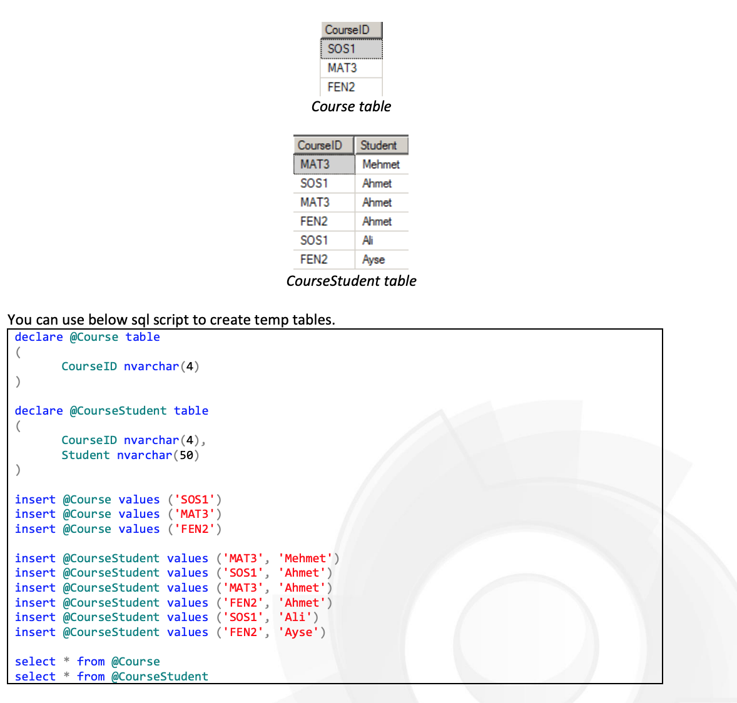

**QUESTION 2**

—

Create a sql query to find the average TotalAmount for the last 3 values for each Customer. If a customer does not have 3 operations, then the result should be null.

with Cus as (

select o.* ,

RowNbr=ROW_NUMBER() over (Partition By CustomerId Order By EventDate Desc)

from CustomerOperations o

)

select x.CustomerId, avg(x.TotalAmount) as AVGAMOUNT, c.CustomerName

from Cus x

inner join Customer c on x.CustomerId=c.CustomerId

where RowNbr=3 group by x.CustomerId, c.CustomerName

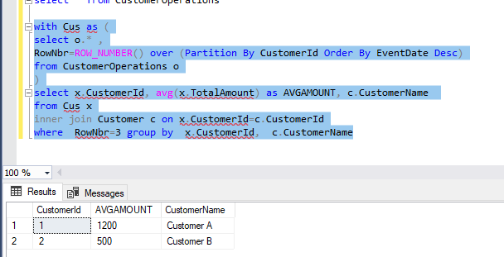

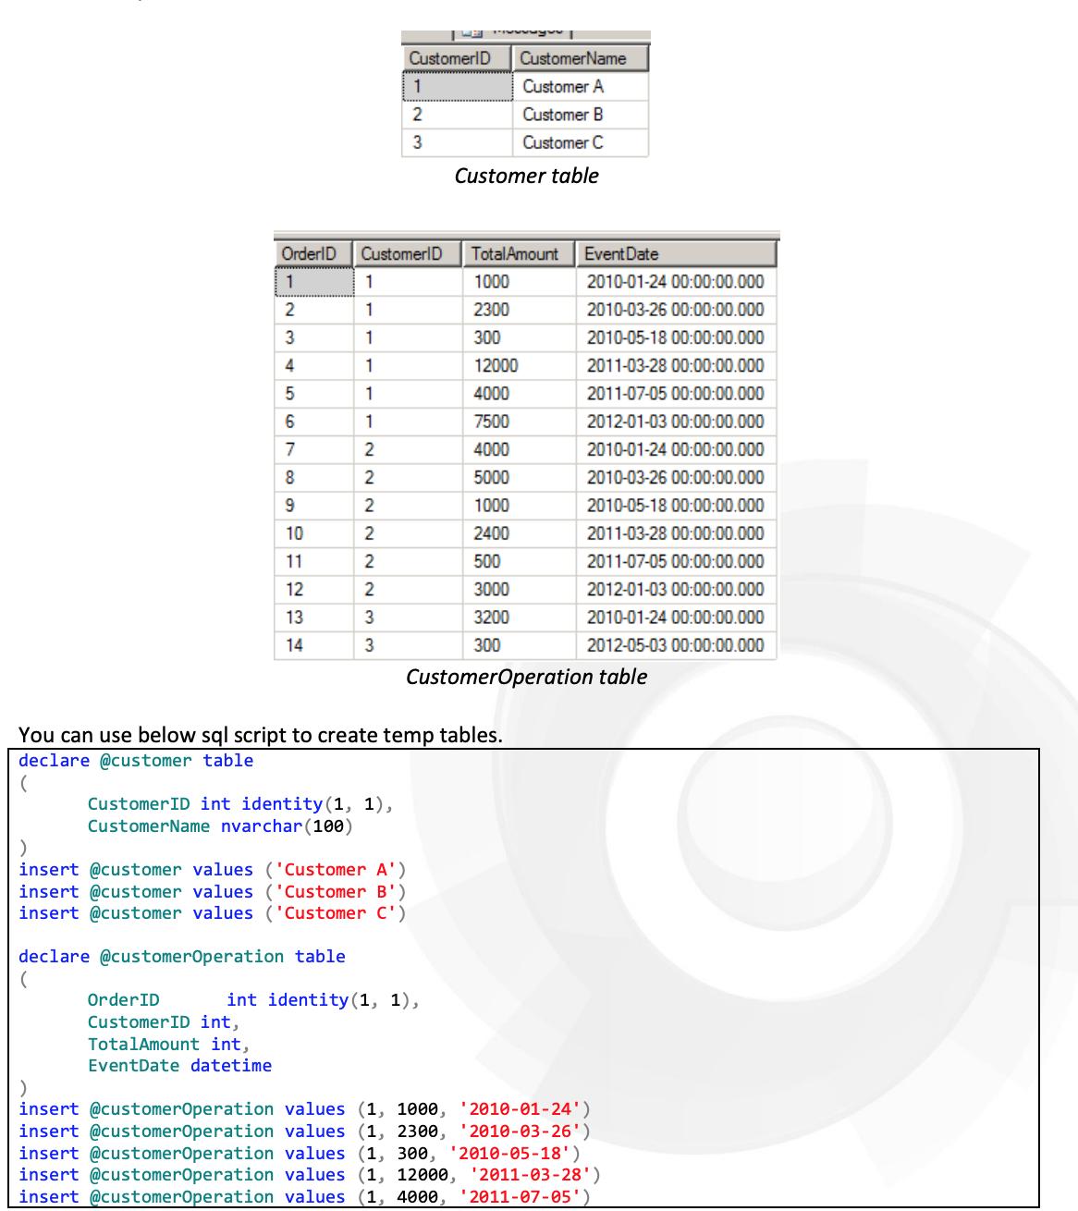

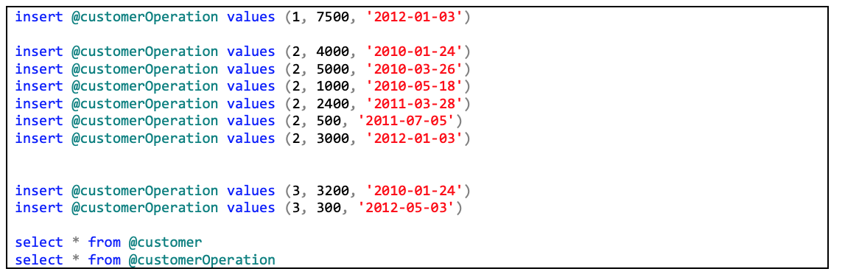

**QUESTION 3**

—

Create two table-valued function;

1- List assigned roles for provided user

2- List assigned users for provided role

Considerations

- Users are defined in “User” table

- Roles are defined in “Role” table

- User’s role assignment are stored in “UserRoleAssignment” table

- A role can present several roles that are stored in “RoleRoleAssignment” table

select q.UserName, m.RoleName from [dbo].[UserRoleAssigment] s inner join Userr q on s.UserId=q.UserId

inner join Rolee m on s.RoleId=m.RoleId

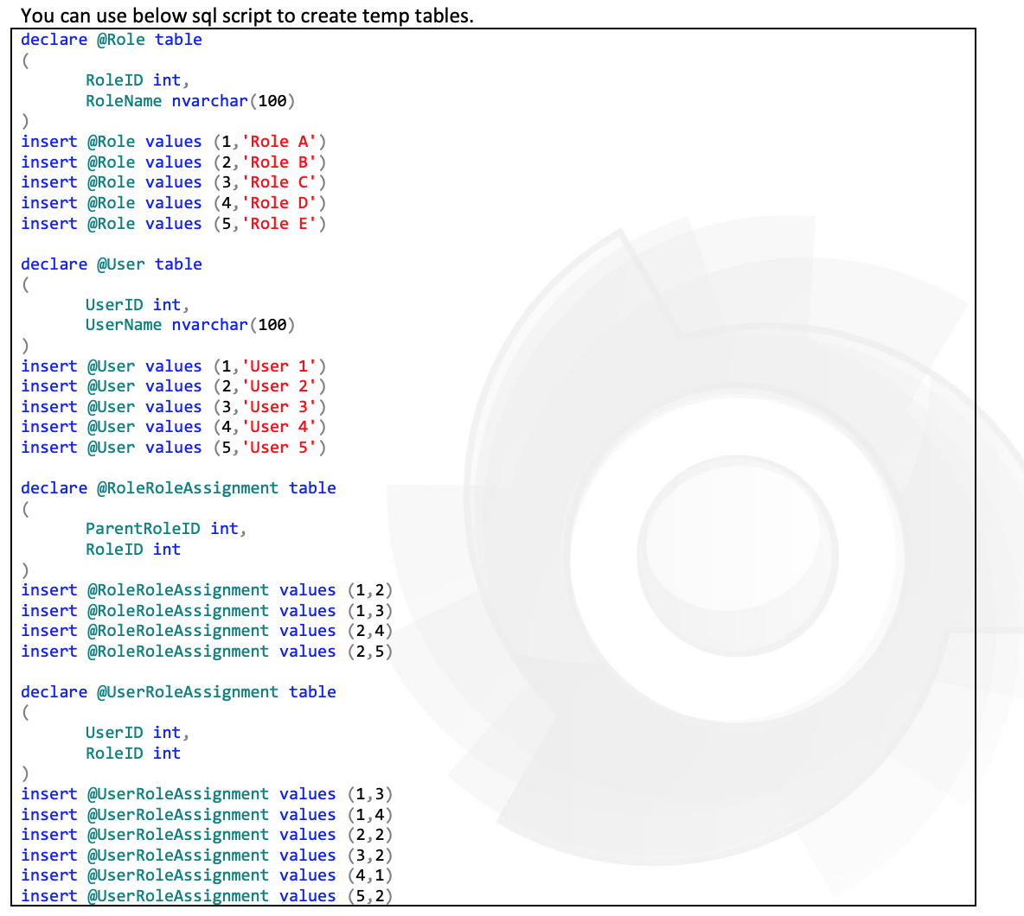

**QUESTION 4**

—

Write needed SQL script to modify table content from State 1 to State 2.

Considerations

- In state 1 “StudentCourse” table contains repeated records

- In state 2 “StudentCourse” table does not contain any repeated records

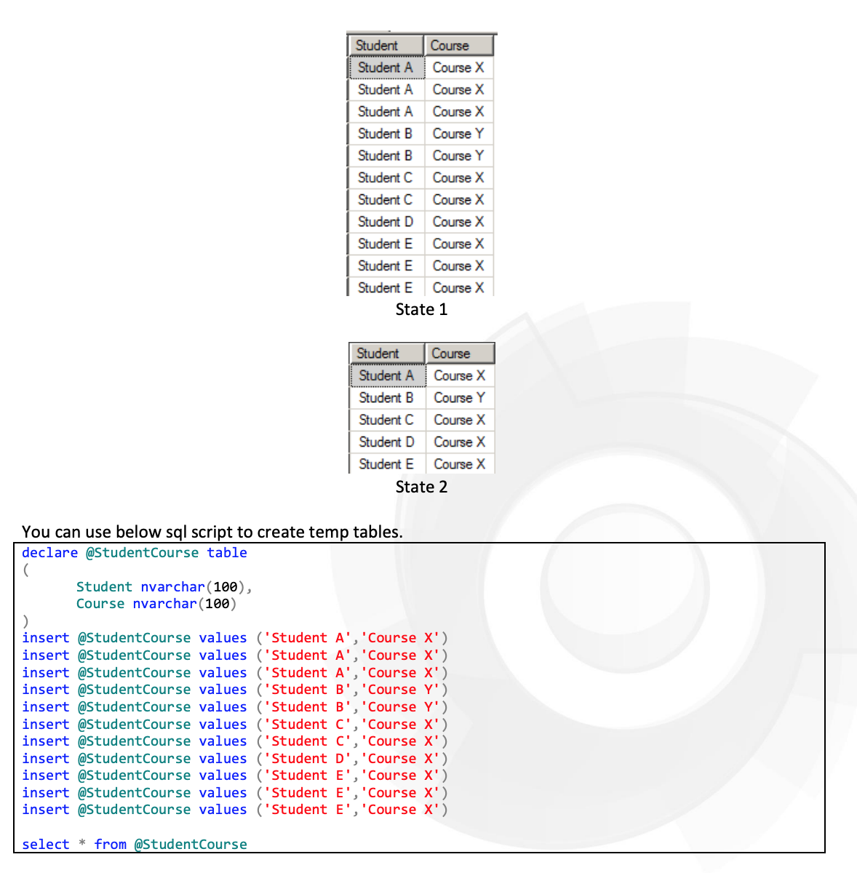

ALTER TABLE StudentCourse ADD PRIMARY KEY(Student,Course)